**NAVIGATION BAR**



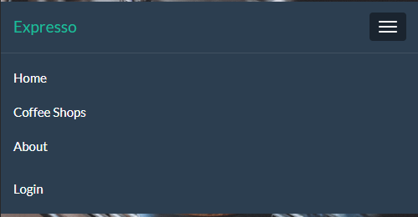

1. The user will see the navigation bar on each page (different looks based on device).
2. The Navigation bar has a home, login, coffee shops, and about options
3. A user can click on any of the option and go to that specific page.

Home Page

*PICTURE GOES HERE*

1. The Home page displays a picture of coffee and acts as the welcome screen for the user.
2. The user will be redirected to the home page after login, signup, or completed order.

Coffee Shops

*PICTURE GOES HERE*

1. The Coffee Shops page will display name location, and phone number of each coffee shop and allow the user to pick which shop they would like to purchase from.
2. The coffee shops option also has a drop-down menu that allows them to go straight to the coffee shops menu of their choice. This makes it easier for the user to expedite purchases if they already know which coffee shop, they would like to purchase from.

Login

*PICTURE GOES HERE*

1. The Login page will allow the user to access their account.
2. If the user does not have an account, they can create an account by clicking the “Create new account” button.
3. The login page will take the user back to the home page after a successful login with their name displayed.

Signup Page

*PICTURE GOES HERE*

1. The Signup page is access by the user through the login page.
2. The Signup page will acquire the user’s username, password, first name, last name and email.
3. After the user successfully creates an account, they will be redirected to the home page.
4. The user must have a unique username, and a password with more than 8 characters and at least 1 upper, lower and special character.

About

*PICTURE GOES HERE*

1. The About page will list why Expresso was created, what Expresso’s purpose is, as well as who made Expresso and why.

Contact

*PICTURE GOES HERE*

1. The Contact page will have an email for users to send complaints, compliments and other questions to.
2. The contact page will also relist all shops and their information incase they wish to contact and individual coffee shop also.

* Need a page for orders.